 

**Good Principles When Visiting Vulnerable Adults**

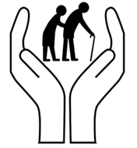**Pray beforehand**

Whatever the reason for your visit, remember to ask for God’s help and guidance. This could be a time of preparatory prayer before you leave your house, a short prayer on the way the door – or both!

**Timing**

Think about the most appropriate time for a visit. For example, early evening can be difficult for families with young children; elderly people may be unhappy about answering the door after dark – even if you arrange the visit in advance.

**Arranging Visits**

Whenever possible, contact the person in advance, by telephone or letter, to find a mutually convenient time to visit.

It is helpful if you say why you are visiting. This will enable the person visited to understand the reasons behind the visit – and give them the opportunity to informally consent (or not) to the arrangement.

**Visiting in Someone’s Home**

Always wait to be invited in and go into the room that the person indicates. Don’t assume that you will always be asked into the same room!

Look for clues of to where to sit down. Spectacles left on the table, an open book or magazine, the TV remote control, etc are all indicators that this is someone’s usual seat – so avoid sitting there. If in doubt, ask the person you are visiting where they would like you to sit.

Don’t follow people into other rooms, for example, into the kitchen if they are making you a drink.

Unless the person you are visiting is confined to bed, never go upstairs in a house – even to go to the toilet!

If you are visiting someone who is in bed, always check to make sure that it is alright for you to go upstairs and then that it is alright to enter the room. These are personal areas of a person’s home and they may need time to be properly dressed, etc before greeting visitors.

Never go into other rooms in the house alone. It may seem unlikely, but if the person you have visited loses or mislays something valued, you don’t want to be accused of taking it.

Never look through drawers or cupboards – even I the person wants you to look for something for them. It’s better to look together then there can be no misunderstandings.

Never agree to take something from a handbag, briefcase, etc. Take bag to the person and allow them to open it and look for what they want.

**During a Visit**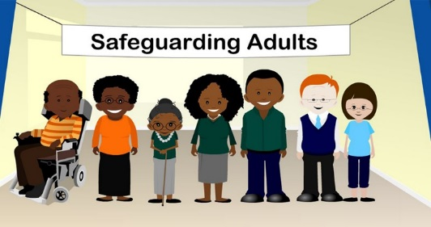

In all visiting, it is helpful to put yourself imaginatively in the other persons position. The thoughtful, sensitive visitor is the most welcome.

**Ending a Visit**

Be aware of the time during your visit (but avoid frequently looking at your watch!).

Don’t be afraid to end a meeting earlier than planned if the person seems to be tiring.

Give a ‘five minute’ warning: “I’m going to have to leave in a few minutes. Is there anything else you’d like to talk about before I go?”

Offer a further visit, if appropriate – and an indication of when this is likely to be.

If this is one of a series of planned visits make a firm appointment for your next visit.

**Protection of the Visitor**

We recommend that if you are visiting on behalf of the church/as part of a parish visiting team you visit in pairs.

If for any reason you find yourself visiting alone, always let someone else know when you will be visiting and for how long. If you are concerned about confidentiality, leave your mobile telephone number – or a note of where you are in a sealed envelope. Never visit someone of the opposite sex alone in their home.

Being part of a team – visiting vulnerable adults, taking out communion – means that there are other people around to help and support the individual team members. When you visit as a member of a parish organised team, you need to let the team know what is happening.

Everyone organises their teams differently, but there will usually be someone who acts as a ‘co-ordinator’, who sorts out who is going to visit a particular person etc. They also need to know when you have visited – and of any outcomes that need following up.

**Record Visits**

Make a note of the date of your visit, the time of your arrival and the length of time you stayed. This helps you keep a record of your visiting and can be useful if the person you are visiting is confused about when you last visited.

**Good Practice when Visiting Residential Settings**

Sign in and out

Introduce yourself to care staff, even if they are hard to fine, and say what you are doing

If someone wants to be moved find a member of staff, don’t try to move them on your own.

Apply all the same principles as home visiting. If you witness or are told anything you are uncomfortable about please discuss this with your parish safeguarding officer and/or Diocesan Safeguarding Advisor.

**Identity Cards**

Always take your identity card when you are visiting – even if you know the person you are visiting well. There may be someone present, e.g. a family member or a health or social care worker, who needs to be reassured that you are a genuine visitor from the church.

**Food and Drink**

Don’t offer sweets, drinks or other food items to people who you are visiting. You don’t know what they are able to have and they may not want to refuse for fear of offending you.

**Medication**

Never offer ‘over the counter’ medicines to the people you visit. Painkillers, cough medicines, throat pastilles, etc. can all have side effects and may not be compatible with other prescribed medicines the person may be taking.

**Handling Money and Gifts**

It can be very easy for someone to be confused about money. Ensure that if you are part of a visiting team you check your parishes’ policy with regards to handling money.

If you are asked to go shopping for someone you should again check with your parish regarding its policy on shopping for people and handling money.

If someone wants to give money to the church, always put it in an envelope and mark it on the outside as a donation – and get the Treasurer to acknowledge receipt or get them to sign up to the envelope scheme so that monies can be traced.

If someone wants to give you possessions that they own for a church fete/Christmas fayre etc. ensure that the person giving you the possession has the mental capacity to understand the size and the value of the gift they are giving.

You should never take something for going.

**Physical Movements & Contact**

If someone in a residential establishment or hospital wants to be moved, find a member of staff – don’t try and do it yourself. Avoid physical contact with people in nightclothes – they can be less concealing than normal day clothes and it can cause embarrassment.

**Confidentiality**

It is vital that things said to you remain confidential, however if there are safeguarding issues you should ensure that people are aware that you have a duty to report them.